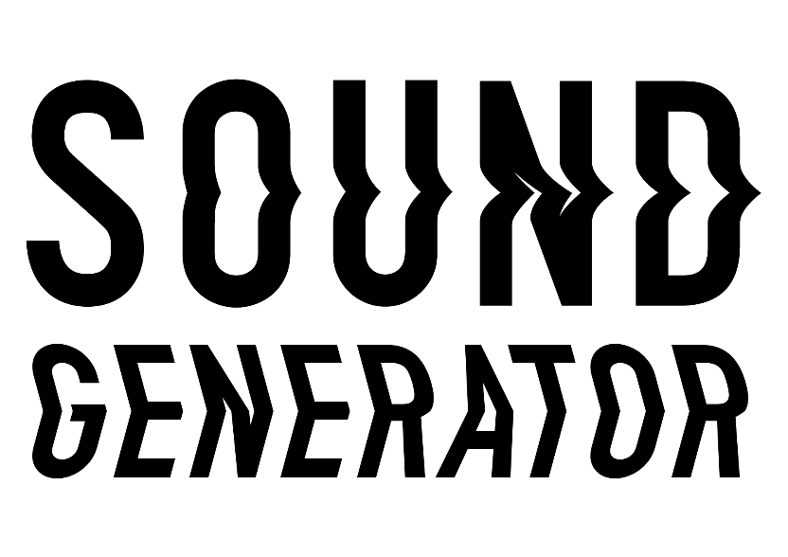

Research and development support for
new music projects

GUIDELINES AND INFORMATION
WHO WE ARE:
Sound UK brings music creators and the public together to experience extraordinary music nationwide.

We have a strong track record in delivering high quality, distinctive projects in any setting - from major arts centres to grass roots venues, villages to major cities, beaches to online.

From National Trust to Barbican Centre, we have collaborated with over 100 leading organisations.

We’ve given 215,000 people from Cornwall to Hull the opportunity to experience exceptional new music. Since 2001 we’ve supported over 260 of the world’s most original music creators of all genres through more than 90 acclaimed national projects.
Our projects bring excellent music to diverse audiences and explore wider issues, such as the environment and mental health.
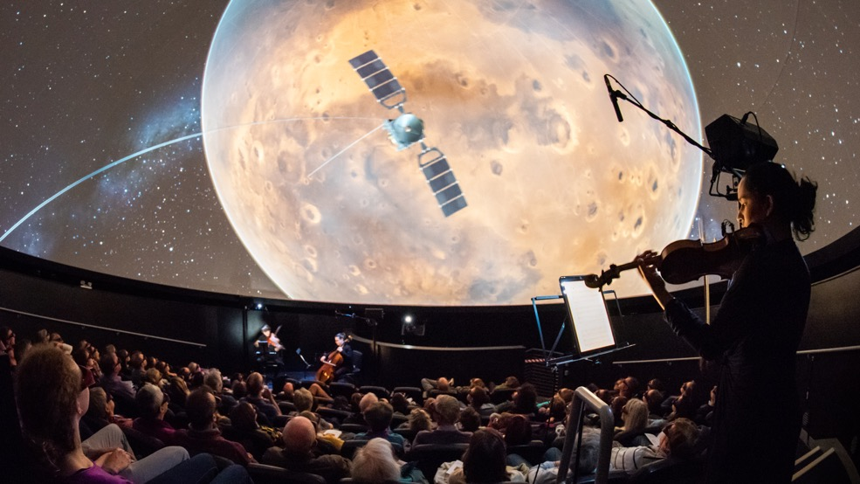
The Planets, We The Curious c Lee Pullen

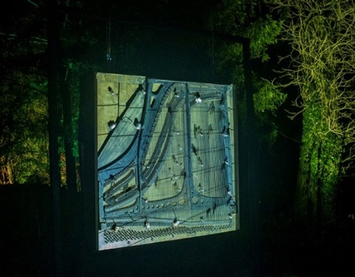
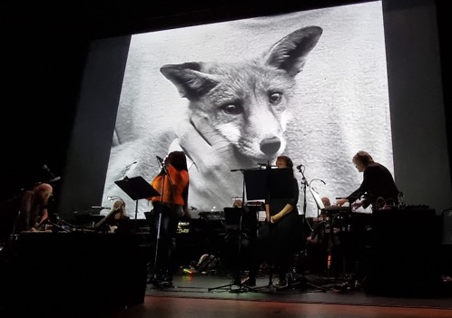
Kathy Hinde Piano Migrations - Alight
Arcadia Live

WHAT IS SOUND GENERATOR?
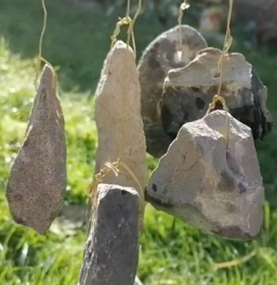
Now in its third year, Sound Generator is a research and development (R & D) programme that supports artists and seeds the development of an ambitious new project.
‘Rock Wind Chime’ prototype
- Andrew Woodhead
Each year six early career music and sound artists spend six months developing and testing their project, supported by mentoring from a range of experts.
By the end of the programme artists will have thoroughly explored their initial idea and tested that they can make it work, ready for the next stage of full commissioning and public engagement.
During the process artists will be able to try out new approaches, learn from others, increase their network and develop their practice.

Projects can be:
- For indoors or outdoors
- Suitable for venue touring or site specific
- Digital, installation or live
- Music, sound or multi-disciplinary
- Designed to reach a new audience, work with a specific community or respond to the world we live in.
Following an open call, six artists will each receive an award of £2200 to research and develop their idea across six months (June to November 2023).
In addition to £2200, the programme includes access to the Sound Generator Network with support sessions from a range of exceptional mentors, plus opportunities to connect with other artists on the programme.
The R & D will culminate in the creation of a short audio or video sample of the project, and a proposal for its delivery. These will be presented by each artist at a sharing event at the end of the programme and sent out to a wide network of industry contacts.

WHO IS IT FOR?
- UK* creators that reflect the full cultural diversity and gender spectrum of the UK
- Creators with 5 – 10 years professional experience
- Creators who want to develop a new idea that extends their practice, with public interaction in mind.
- Artists pushing the boundaries of contemporary music. Working within, but not exclusively, jazz, sound, folk, classical and electronic music, plus all points in between.

*we define a UK artist as someone who has been based and working in the UK for more than 5 years.

WHAT ARE WE LOOKING TO SUPPORT?
We’re looking to support the research and development of artists and ideas:
- that demonstrate ambition and quality
- in a range of formats including live, digital, installation (excluding recordings)
- that extend artistic practice and discipline (e.g. extending your craft, using new tech, interdisciplinary work)
- suitable for a variety of settings and locations, arts and non-arts
- address public engagement or participation
- that seek to reach a diverse audience or focus on reaching a particular target audience e.g. young people
- that might change the way we think or feel for the better e.g. about the environment, social issues, or our own wellbeing

We are NOT looking to support:
- Projects that already exist
- Album recordings
- Artists with more than 10 years’ professional experience

You can meet the Sound Generator 2021 artists here and 2022 here.
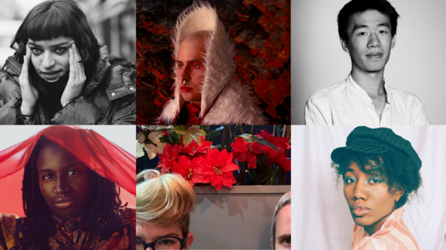

Sound Generator 2021 Artists

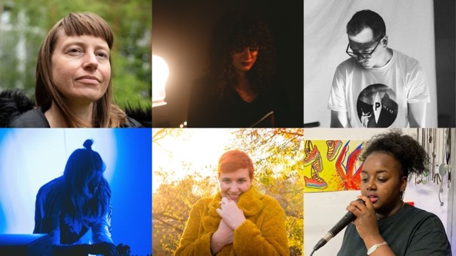
“Sound Generator was a great experience, I hope the programme continues to give more UK based artists working with sound a chance to experience such a good R&D programme.”
Jordan Edge, Sound Generator 2021
“The best thing about the programme was having the time, conversation and mentoring to fully develop and condense a big idea into something that is ready for an audience.”
Lori E. Allen, Sound Generator 2021

Sound Generator 2022 Artists
“We learnt so much and mentoring + support was very helpful in furthering our ideas. I think it also puts us in a better position to get further funding and for potential future collaborations.”
Daphnellc & Ambra, Sound Generator 2022
You can get an idea of the range of work we produce by looking at our past projects.

HOW DOES IT WORK?
- INITIAL MEETING: One-to-one consultation with Sound UK producers to clarify your idea and R&D needs. Together we will design how best to use the award and identify mentors.

- MONTHLY CATCH UPS: Phone or video call with your designated Sound UK producer (Maija Handover or Polly Eldridge) to check in on how you’re doing.

- ARTIST MEET UPS: three Sound Generator meet ups with guest speakers e.g. funders or artists. These may be online or in person. They are an opportunity to get to know the other Sound Generator artists, share ideas and learn from each other as well as the guest speaker.

- MENTORING: 10 hours’ support and advice from up to five mentors to help you develop and test your idea. These include:
- high level creative, technical, communication and funding professionals
- programme directors from a range of partners (e.g. venues, heritage organisations and public spaces).
You may want to use that time with just one mentor or across a number of different mentors. The consultation with Sound UK will help decide what will work best for you.
- SHARING EVENT: At the end of the programme, all Sound Generators come together to present their project sample to each other. With advice from Sound UK producers, artists create a project outline document which is sent out to Sound UK’s network.

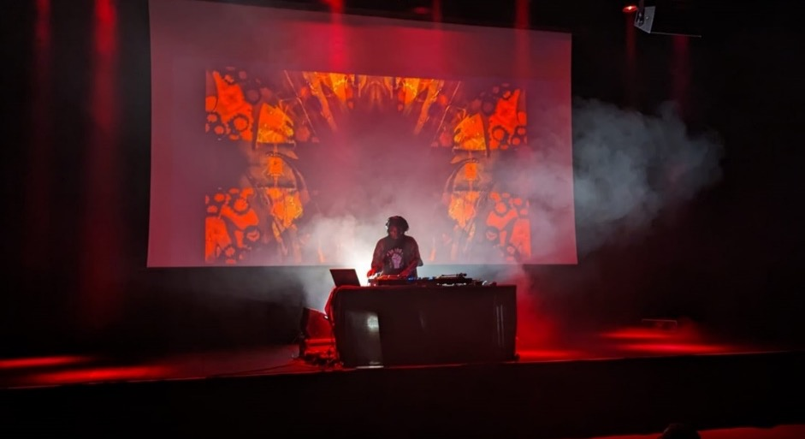

NikNak Sankofa at Kings Place

HOW CAN AWARDS BE SPENT?
Sound UK will help each artist decide how best to spend their £2200 award across the 6-month programme.
The award will need to cover your time and any costs to create your idea proposal and audio or visual sample. For example you might want to buy some software, book a recording or rehearsal studio, employ a wider creative team to try out work in progress or go on site visits.
We anticipate the majority of the award will go towards your time on the project.
THE OUTCOME
By the end of the programme the six artists will have prepared a video or audio sample and project outline/ proposal for their ideas.
Sound UK will help identify key industry partners to present your idea to. These will include organisations and promoters working across music genres as well as other disciplines and different settings.
Each year a proportion of Sound Generator projects will be fully produced by Sound UK as part of our annual programme (pending funding).
HOW DECISIONS WILL BE MADE
Sound UK producers present a long list to a panel of leading industry figures including a funder, an artist and a venue.
Proposals will be considered against the following criteria:
- Artistic vision and quality
- Track record of creator for creating and delivering original material
- Will a public execution of it be feasible
- Has the audience for the project been considered, and how they will engage / participate
We seek to balance:
- Diversity of creators
- Diversity of music and creative styles
- Geography of creators across the country

ACCESS
We are committed to making Sound Generator accessible to all and supporting applicants facing barriers to applying.
If you have any access requirements, require the application form in an alternative format, or need support putting in an application, please contact us at info@sounduk.net and tell us what you need to apply.
HOW TO APPLY & DEADLINES
Have a good look at our website to find out more about Sound UK’s work.
Complete the online application form here: Sound Generator application form
Please note there are character limits on some of the answers. Please stay within them or your answer may be cut off.
If you need to apply by video please let us know.
If you have any questions about the form, please email info@sounduk.net

DEADLINE: 28 April 2023 at 5pm
AWARD DECISION: 25 May 2023
SHARING EVENT: 30 November 2023

